Problem Statement : Ticket Tracker Application

You are required to create a CRUDS (Create, Read, Update, Delete, Search) functionality for a ticket tracker application.

Home Page:

New Ticket create option .

All list of tickets in home page.

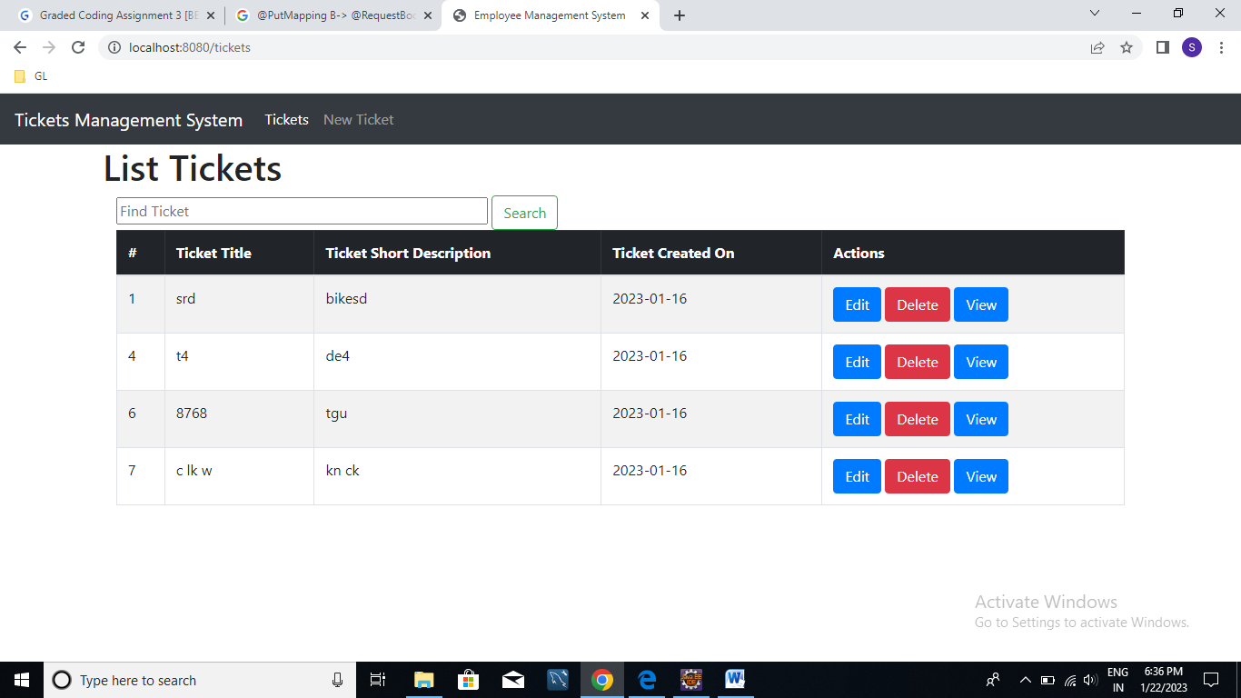

1. Create new Ticket:

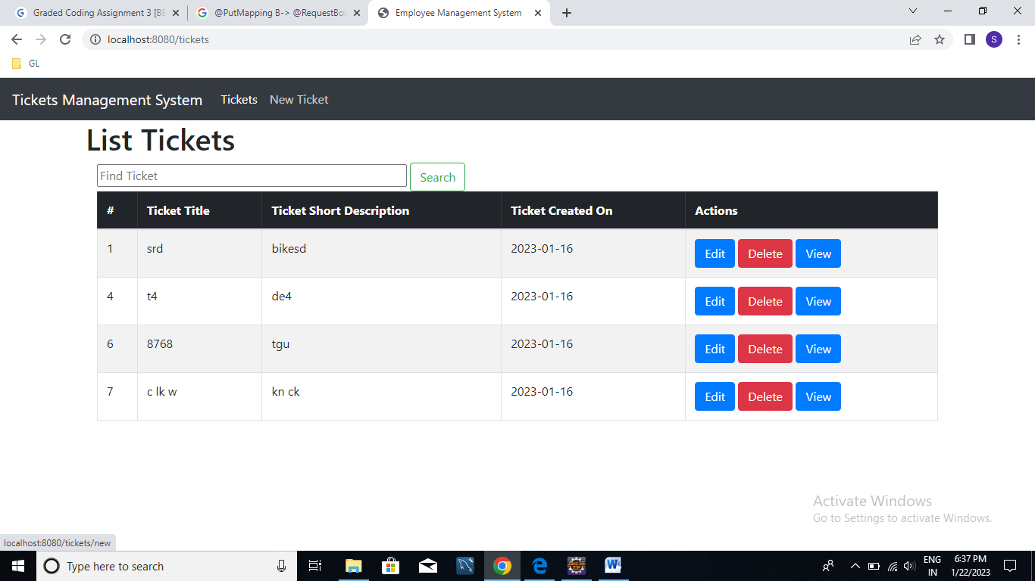



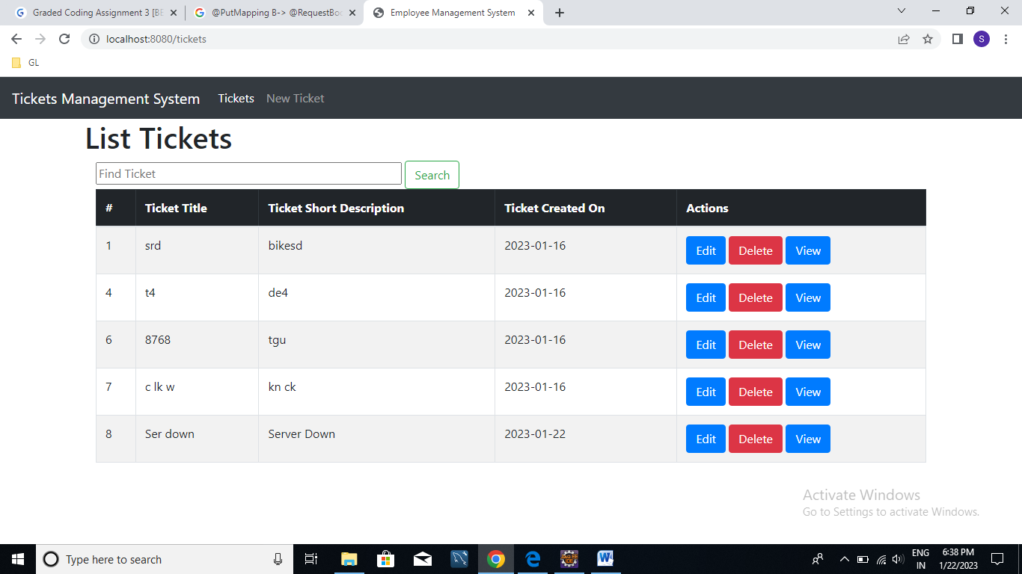

New Ticket created successfully with given details and with id.

1. Update Ticket:

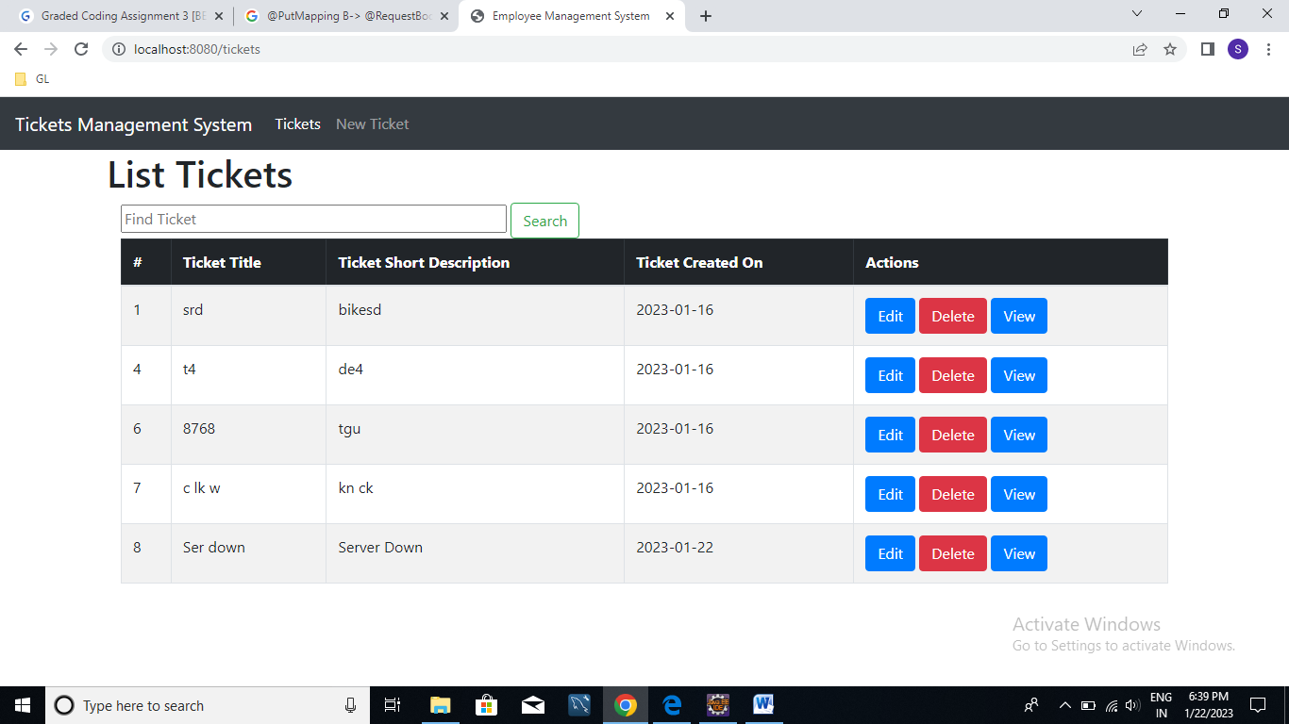

Updating ticket with id 8

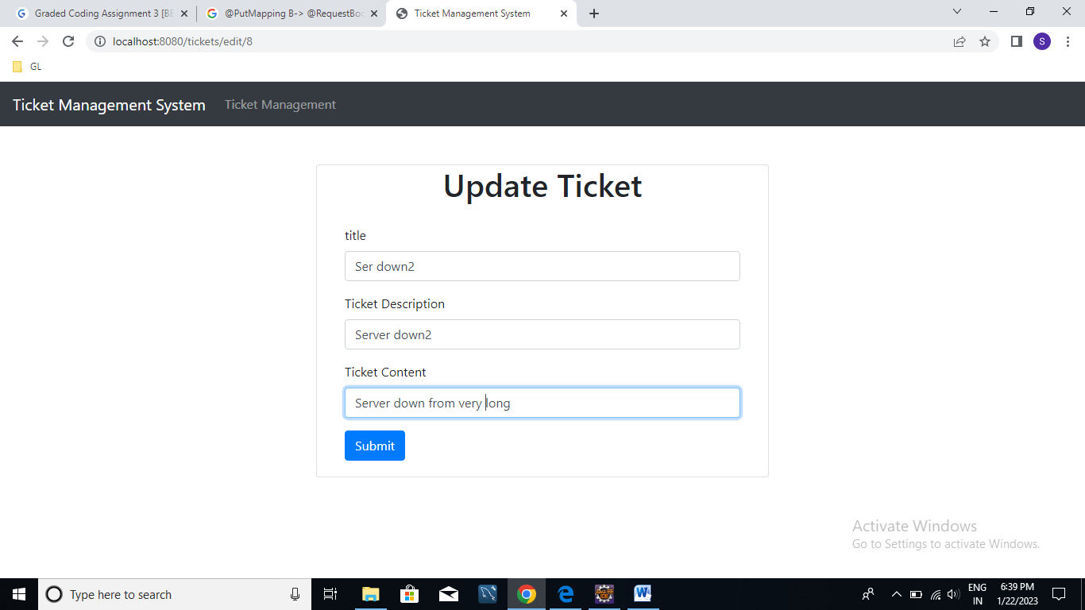

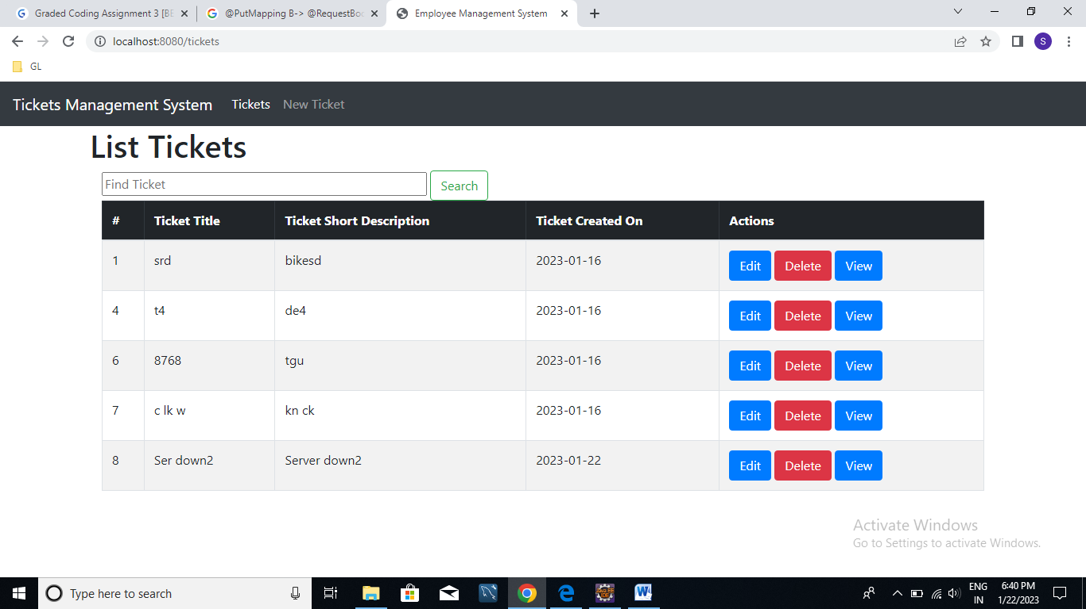

Ticket with id 8 details got updated.

1. View Ticket (Read):

View details of ticket after clicking on view button.

Viewing ticket 8.

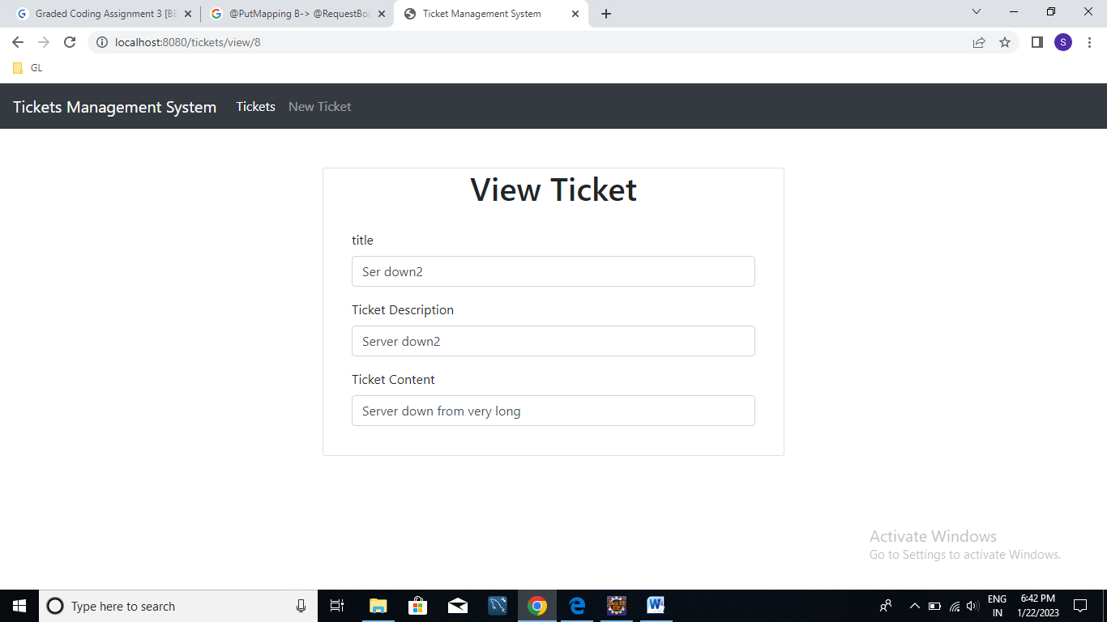

1. Delete ticket:

Delete ticket with id 8 by clicking on delete button.

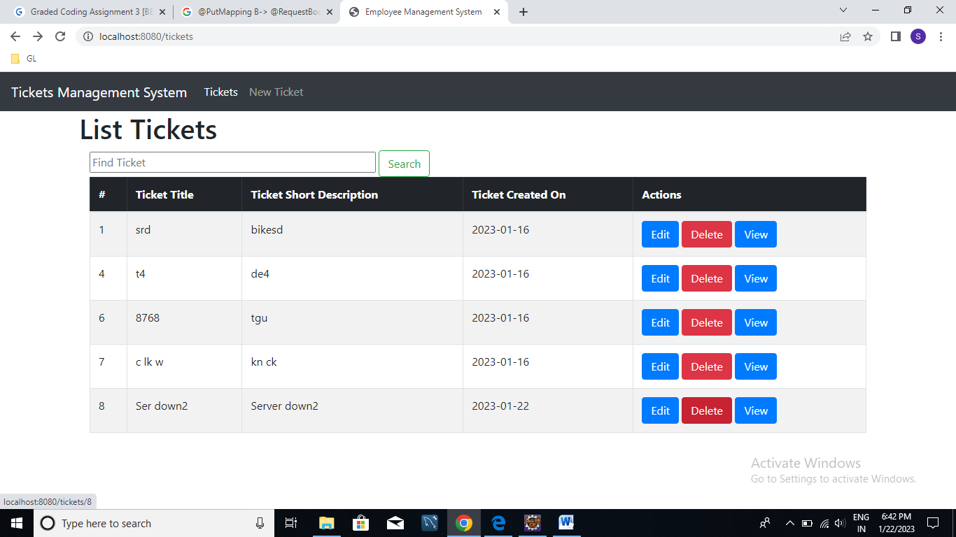

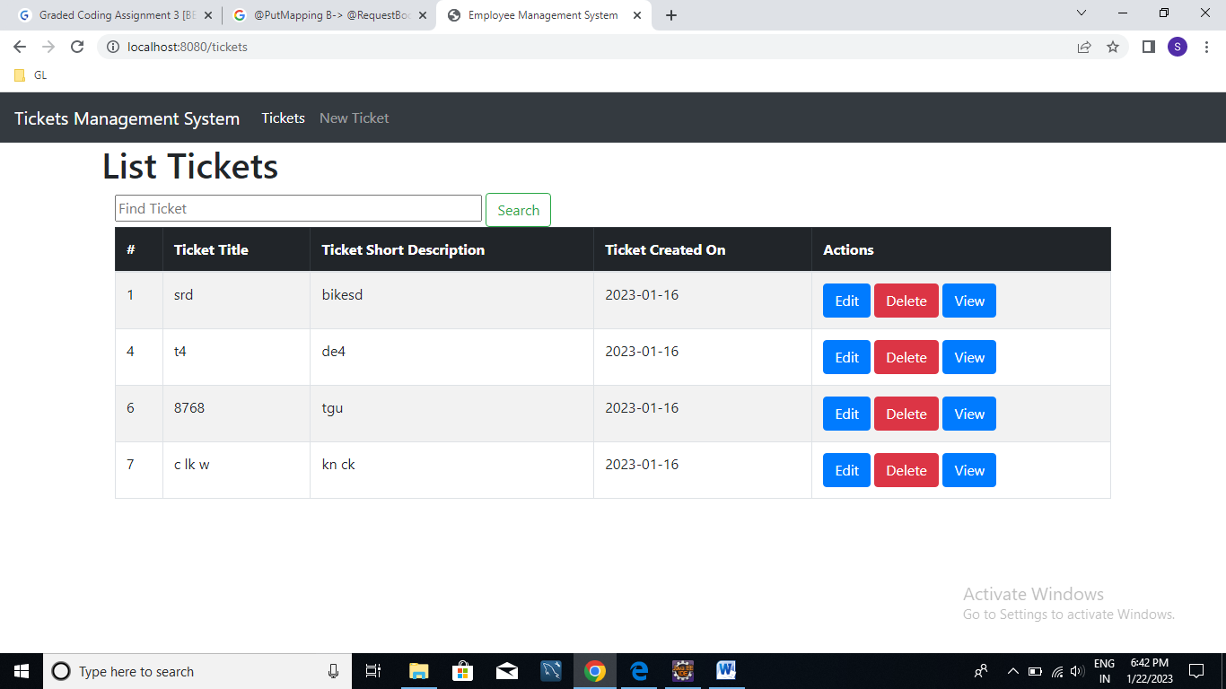

Ticket is deleted successfully.

1. Search Ticket:

